Dynamic Systems

& Control B: Half Car

Rig Experimental Investigation:

Group 3 - Sebastian Schroder (13611140), Gabrielle Mullen (1294 9309), Jawad Rashid Rakin (13839814)

Dynamics Systems and Control B, Autumn 2023

Repo - <https://github.com/DARKMOONlite/DS-C_B-Half-Car-Rig-Analysis>

Table of Contents

Table of Figures: 3

Highlights: 3

Aim: 3

Methodology: 4

Experimental data 4

Model/simulated data 5

Data Analysis: 5

Discussion & conclusions: 6

Experimental vs Numerical 6

Effect of Damping 9

Determining of Critical Damping: 10

Effect of additional Mass 12

Effect of Drop Configuration (Centre vs LHS) 12

Other Considerations 13

Limitations & room for improvement 16

Limitations of data collection 16

Model limitations 17

References 18

Appendices: 19

Appendix A: Safety Form 19

Appendix B: Experiment set-up pictures 20

# Table of Figures:

Figure 1Flowchart of DAQ and component setup for half car rig 4

Figure 2 Diagram of model 5

[Figure 3 Simulink Model 6](https://studentutsedu-my.sharepoint.com/personal/sebastian_schroder_student_uts_edu_au/Documents/Microsoft%20Teams%20Chat%20Files/Half_Car_Rig_Experimental_Investigation.docx#_Toc137675334)

Figure 4 Mode Shapes 7

[Figure 5 Heat Map 7](https://studentutsedu-my.sharepoint.com/personal/sebastian_schroder_student_uts_edu_au/Documents/Microsoft%20Teams%20Chat%20Files/Half_Car_Rig_Experimental_Investigation.docx#_Toc137675336)

Figure Modal Shapes Animation 8

[Figure 7 Effect of Damping on simulated data 9](https://studentutsedu-my.sharepoint.com/personal/sebastian_schroder_student_uts_edu_au/Documents/Microsoft%20Teams%20Chat%20Files/Half_Car_Rig_Experimental_Investigation.docx#_Toc137675338)

[Figure Damping ratio to hydraulic pressure. 9](https://studentutsedu-my.sharepoint.com/personal/sebastian_schroder_student_uts_edu_au/Documents/Microsoft%20Teams%20Chat%20Files/Half_Car_Rig_Experimental_Investigation.docx#_Toc137675339)

Figure 9 Response under critical damping 11

Figure 10 Effect of Mass on experimental data 12

Figure 11 Peaks of FFT for various damping levels 12

Figure 12 Centre vs LHS 13

Figure 13 Settling time Centre vs LHS. 14

Figure Lab data FFT – centre, undamped, no mass 14

Figure : Diagram of phase and magnitude of frequency using CPSD function**.** 15

Figure : Zoom in of modes of vibration with legend. 16

Figure Picture of dropping crane, possible reverberation, leaning. 17

# Highlights:

* Critical damping value of 3854
* LHS drop out of phase – dominant response is m1 roll and m1 bounce; Centre drop is in phase – dominant response is m1 bounce.
* Increasing mass increases amplitude of vibration due to increased kinetic energy and increased relative initial displacement.
* Damping decreases steady state response period.
* Losses related to heat and friction, human error and model limitations.

# Aim:

The goal of this investigation is to explore the half car rig through experimental and numerical analysis and generate conclusions (rear two wheels). Specifically, the goal will focus on the effect that increasing the mass of the sprung mass has on the oscillations of the rig, as well the roll of damping in such a system. Conclusions will then be drawn through numerical and analytical methods that should attempt discuss/prove or disprove the efficacy of results gathered. This should allow for others to replicate the experiment while adding comments on improvements to be made.

# Methodology:

## Experimental data

There are two data sets to compare; simulated ‘numerical’ dataset developed by creating a model on MATLAB and ‘experimental data’ collected in Building 11 Half Car Rig at UTS. The Goal of the experimental component is data collection of the half car rig. The rig has been equipped with 4 LVDTs (Linear Variable Differential Transformer) that measure the linear translation of 4 locations of the rig. These 4 measurements were converted into units that represent the 4 DOF (degrees of freedom) of the half car rig based off a matrix of differential equations.

The following steps outline the process for taking 1 set of data.

1. Ensure LVDTs are attached at all 4 locations on the rig, 2 on the ends of the sprung mass and 1 on each unsprung mass.
2. Modify level of damping and/or masses on either side of the sprung mass.
   1. Damping (0, 500, 1000, 1500)
   2. Additional mass (200N 400N equally balanced on sprung mass)
   3. Change drop location (Centre & Left-Hand Side)
3. Using the roof crane, raise the half car rig 100mm, or just before touching the top of the rig.
4. Start capturing data on the attached analysis software.
   1. Set appropriate voltage for LDVTs, physical channels, trigger condition (falling edge), time interval and sampling rate of 5000 Hz.
5. Release rig by triggering the crane release. Dropping the rig and activating the trigger on the data collection.
6. Leave rig to oscillate until rig has become stationery and data collection is over before touching the rig again.
7. Repeat, the test 3 times, averaging the results to remove inconsistencies in the procedure.
   1. Repeat for all combinations 3 times (data set of 90 tests averaged to 31 sets of data with unique condition combinations.

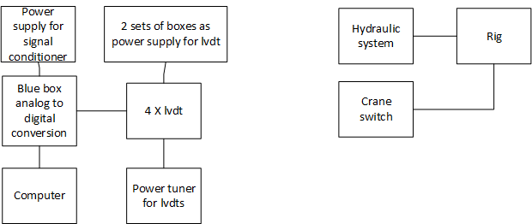

Figure Flowchart of DAQ and component setup for half car rig

LVDT Data collected during this experiment can be found within the “LAB TEST FOLDER” folder, it has been sorted based on the type of test as well as the level of damping and added mass. To compare with the model, we transformed the displacement/time data to the 2 top LVDTs were combined and averaged to represent mass 1. mass 2 and 3 are considered unique point masses at each end of the car suspension. We used the given parameters where relevant and made changes as we saw fit.

Table Summary of provided parameters.

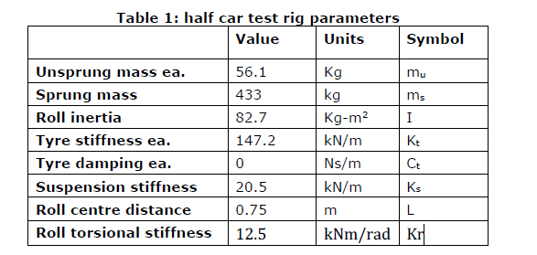

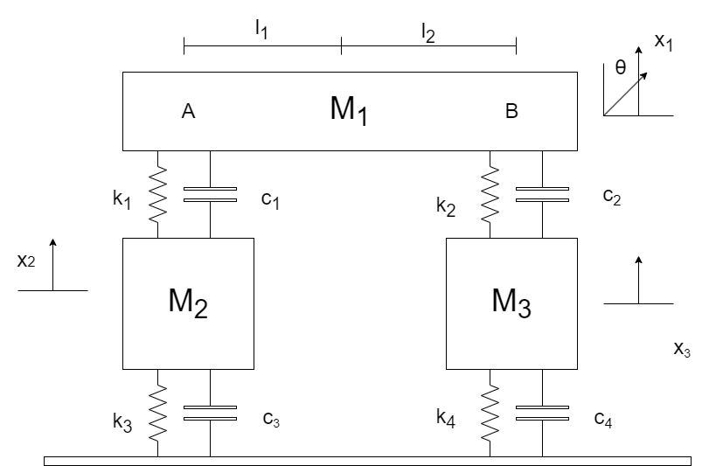

Figure Diagram of model

Figure 2: Diagram of model. See the EOM and development of model in detail in the “documentation.mlx” file on GitHub. Roll inertia was increased when masses were added. L is 1.25 meters and torsional stiffness was multiplied by theta. Nyquist frequency 2500 (sampling frequency was 5000.

## Model/simulated data

# Data Analysis:

Data analysis has been completed and documented inside the “documentation.mlx” file, ensure that MATLAB 2023A is used to ensure Simulink runs the model correctly.

# Discussion & conclusions:

## Experimental vs Numerical

**Natural Frequencies identified (Hz)**

The natural frequencies determined from experimental analysis through the fast Fourier transform, are like those gathered through analysis of the spring and mass matrices that make up the numerical model. This can be accounted to multiple factors.

1. Damping in the system causing a shift in the frequencies of the system.
2. Relatively low spectral resolution for low frequency data due to low spectral resolution. (This could have been improved through increasing the sampling rate)

Table Experimental vs Numerical natural frequencies

|  |  |  |  |
| --- | --- | --- | --- |
|  | *Experimental (Hz)* | *Numerical (Hz)* | *% difference* |
| $$ω_{1}$$ | *1.25* | *1.448* | *+15.8* |
| $$ω_{2}$$ | *2.5* | *3.545* | *+41.8* |
| $$ω_{3}$$ | *8* | *8.719* | *+8.987* |
| $$ω_{4}$$ | *9.75* | *8.82* | *-9.53* |

The below Graph shows the Simulink model designed to be analogous to the experimental rig. This model takes in initial parameters of the system and then outputs the systems response to those conditions. However, there are limitations of this model, such as the simulation having a larger damping effect early in the simulation before taking a long time to completely stop.

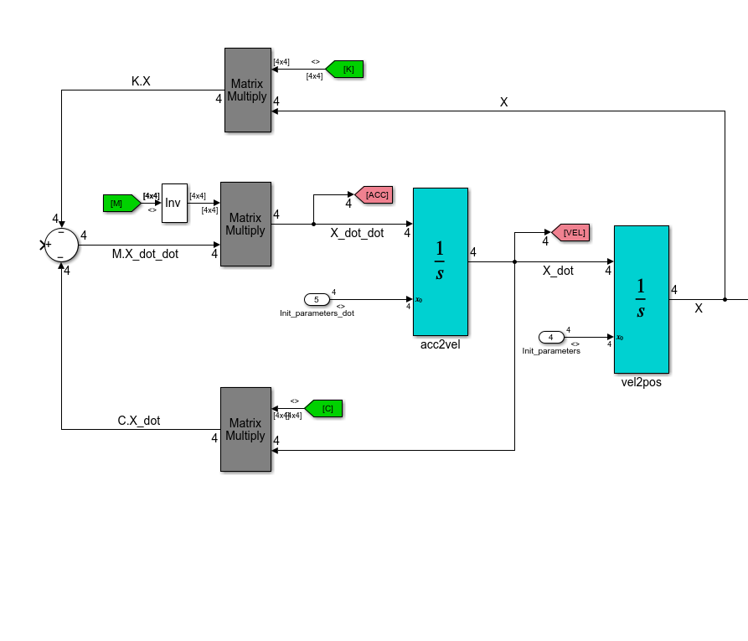

Figure Simulink Model

*Figure X: Block diagram of simulation*

**Mode shapes**

*Numerical (simulated from model)*

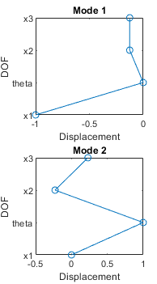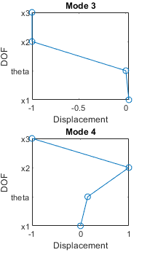

Figure Mode Shapes

**Heat Map**

Heat map below suggests the physical displacement of our systems individual components, e.g., Sprung mass and the two unsprung masses. The Sprung mass is the half car body 1.5 m in length and has 2 motions. 1st row is the $y_{c}$, which is the vertical displacement of the sprung mass. 2nd row represents the roll motion. And the last two represents the unsprung masses.

Table Heat Map terminology

|  |  |
| --- | --- |
| Document terminology | Equivalent heat map terminology |
| $$X_{1}$$ | $$Y_{c}$$ |
| $$θ-theta$$ | $$Ψ-psi$$ |
| $$X_{2}$$ | $$y_{fR}$$ |
| $$X_{3}$$ | $$y_{fL}$$ |
|  |  |

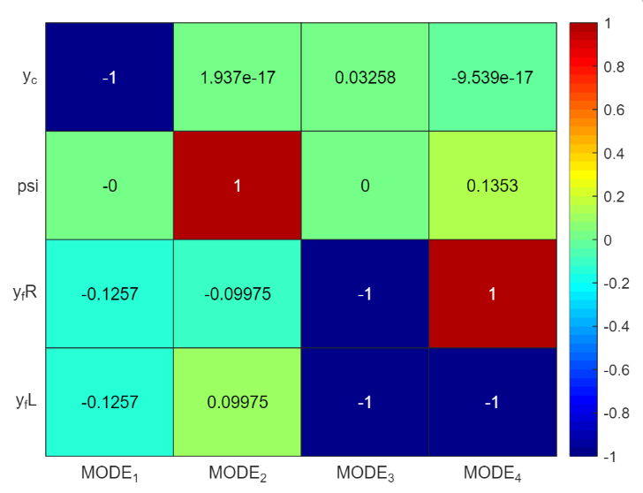The colour code has a number on the right-hand side, which represents the relative displacement. 0 represents no displacement or change in angle and 1 & -1 represents extensive change from rest position.

Figure Heat Map

The 1st column represents the 1st mode shape with the sprung and unsprung masses in phase. There is large motion in $y_{c}$ with the unsprung masses moving slightly. The 2nd column represents that the 2nd mode shape in which there is little bounce, large amounts of roll for the sprung masses and the 2 unsprung masses are out of phase.

For the 3rd mode. The unsprung masses are in phase with each other and out of phase with the sprung mass, while in the 4th there is a relatively large amount of roll with the 2 unsprung masses out of phase with one another.

**Animation of the Mode Shapes.**



Figure 6 Modal Shapes Animation

## Effect of Damping

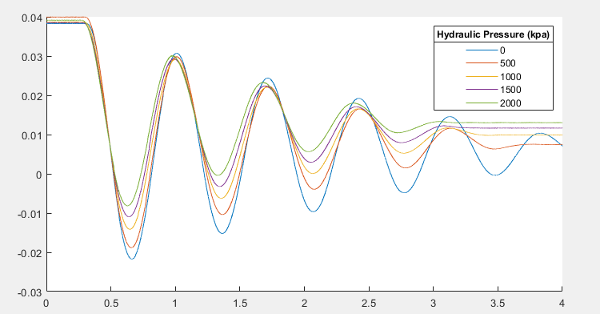Damping has multiple effects on the half car rig. A summary of the sprung masses’ displacement at various hydraulic pressure values has been provided (figure 1). Increasing the damping through hydraulics has the effect of decreasing the settling time of the free system and causes an offset in the steady state response due to the additional force applied by the hydraulic system.

Figure Effect of Damping on simulated data

An important question is how much the system is being damped at each pressure value, to determine this Assumptions can be made to determine the effectiveness of common engineering strategies. Conclusions drawn will then determine whether such assumptions are accurate.

The main assumption is simplifying the translatory motion of the rig to a single DOF system being driven predominantly by a single large sinusoidal wave at $\sim 1.4Hz$. if this assumption is made, is it possible to determine the logarithmic decrement, and therefore compare the damping ratio at different hydraulic pressures.

$$δ=\frac{1}{n}ln⁡(\frac{x_{1}}{x_{n+1}})$$

$$ζ=\frac{δ}{sqrt\left(4π^{2}+δ^{2}\right)}$$

The gathered logarithmic decrement and damping ratios are shown below.

|  |  |  |  |  |  |
| --- | --- | --- | --- | --- | --- |
| Hydraulic Pressure ($kpa$) | 0 | 500 | 1000 | 1500 | 2000 |
| $$δ$$ | 0.292 | 0.390 | 0.430 | 0.455 | 0.462 |
| $$ζ$$ | 0.046 | 0.062 | 0.068 | 0.072 | 0.073 |

Figure Damping ratio to hydraulic pressure.

Figure X

Conclusion: the results are inconclusive. As pressure and force are directly proportional, the force applied by the hydraulic damper should linearly increase with the pressure observed on the dial, this however is not observed. While it could be stated that these differences are caused by differing velocities, this is unlikely as hydraulic systems seem to react relatively linearly with small velocities ($<1m/s$) (Konieczny,L. Burdzik, R. Folega, P. Wieczorek, A. N. 2013) Most likely the difference between expected and results is due to the incorrect assumption that the model can be simplified to a single DOF system.

## Determining of Critical Damping:

The method used is provided by Beskos and Boley (1980) and discussed in the 2001 paper “On the critical damping in multi-degree-of-freedom systems”. (Bulatovic, R. M. 2002)

The eigenvalue problem can be defined by the following equation.

$$\left(λ^{2}M+λC+K\right)U=0$$

Where $U$ is an eigenvector with eigenvalue of $λ$.

$$∴\det\left(λ^{2}M+λC+K\right)=0$$

To solve this equation the use of a polynomial is required, this is formed through the expansion of the above equation to the form of

$$λ^{2n}+a_{1}{ λ}^{2n-1}+…a_{2n-1}λ+a_{2n}=0$$

Where all coefficients of $a$ are expressed by the elements of the system’s matrices

$$Δ=\prod_{i>j}^{ }{{\left(λ_{i}-λ_{j}\right)}^{2}}$$

$$p_{k}=\sum_{j=1}^{2n}{λ_{j}^{k}}$$

$$∴Δ=det⁡(P)$$

$$→P=\left[\begin{matrix}\begin{matrix}p_{0} & p_{1} \\ p_{1} & p_{2}\end{matrix} & \begin{matrix}… & p_{2n-1} \\ … & p_{2n}\end{matrix} \\ \begin{matrix}… & … \\ p_{2n-1} & p_{2n}\end{matrix} & \begin{matrix}… & … \\ … & p_{4n-1}\end{matrix}\end{matrix}\right]$$

The elements of matrix p are based on unknown roots, however the roots of $λ$ are eigenvalues of the state matrices.

$$∴A=\left[\begin{matrix}-M^{-1}C & -M^{-1}K \\ I & 0\end{matrix}\right]$$

$$p_{k}=Trace(A^{k})$$

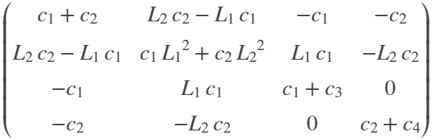To use this however, the damping matrix must be based off a single damping constant ($c$) with each element of the matrix being some coefficient of that constant. To do this, we must make assumptions surrounding the model’s damping matrix.

As $c_{1} \& c_{2}$ are connected to the same hydraulic system, we can state that $c_{1}=c_{2}=c$ and for the time being we will assume that $c_{3}= c_{4}=0$. After substituting back in the values of L, we get the following matrix.

$$C=c*\left[\begin{matrix}2 & 0 & -1 & -1 \\ 0 & 1.125 & 0.75 & -0.75 \\ -1 & 0.75 & 1 & 0 \\ -1 & -0.75 & 0 & 1\end{matrix}\right]$$

Using this along with the known values for the $M \& K$ matrices, we can now determine the characteristic polynomial by solving for the P matrix.

$$Δ= 1.1e8*c^{24} - 9.5e15*c^{22} + 3.6e23*c^{20} -$$

$$7.5e30*c^{18} + 9.2e37*c^{16} - 6.4e44*c^{14} + 2.2e51*c^{12} - 8.6e56*c^{10} -$$

$$1.3e64*c^{8} + 1.3e70*c^{6} + 3.7e76*c^{4} + 1.1e82*c^{2} + 8.2e86$$

After determining the form, the damping constant can be found by finding the real positive roots of the polynomial.

$$c_{a}=2845.0, c_{b}=3854.1$$

By passing them into the characteristic equation of the 2nd order principal leading minor we find that only one of the 2 remain positive.

$$Δ_{2}\left(c_{a}\right)=-33382 \& Δ_{2}\left(c_{b}\right)=27658$$

$$∵Δ_{2}\left(c_{b}\right)>0, c_{cr}=c_{b}=3854.1$$

Conclusions: when applying the proposed critical damping constant to the created model, the following graph accurately exhibits signs of critical damping, with little to no overshoot and a fast settling-time. This acts as proof for the validity of the above calculations and simulated model when within the bounds of the assumptions used. There are however issues with the results gathered; the determinant of higher order principal leading minors for both $c_{a} \& c_{b}$ are negative. Another point is that this is only true when the system behaves under the assumptions provided above, which cannot be replicated in a real experiment.

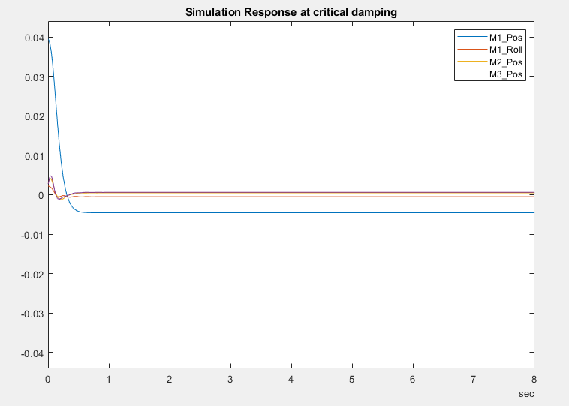

Figure Response under critical damping

## Effect of additional Mass

Mass has 2 effects on the displacement response of the sprung mass. Initially it offsets the steady state response of the system negatively due to the additional forces applied by the attached masses. This has the effect of increasing the relative initial displacement of those tests, thus increasing the potential energy of the system beyond what is expected.

It has the effect of extending the settling time of the system as well as this has the effect of adding additional potential energy into the system, which is dissipated over a longer time span, as evident below.

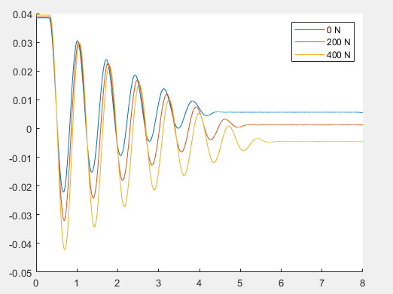

Figure Effect of Mass on experimental data

## Effect of Drop Configuration (Centre vs LHS)

In frequency domain, when dropping from LHS roll and m1 are more dominant and m2 and m3 bounce are out of sync. Dropping from centre, m1 bounce mode is dominant, m2, m3 and roll have very small responses but are in sync.

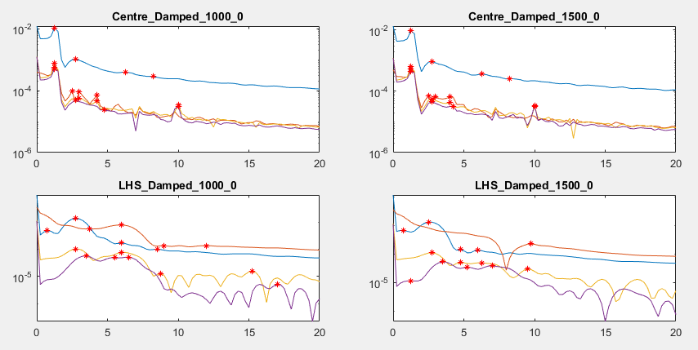

Figure Peaks of FFT for various damping levels

Figure X: Marked peaks for varying damping of lab data.

See in time domain (converted to DOF), most displacement on LHS (where lifted) and m1 though m1 bounce still dominant. Damping high for both, settled almost 2x as fast for LHS drop which was unexpected. For centre damped see all DOF in sync vs clear opposition for LHS.

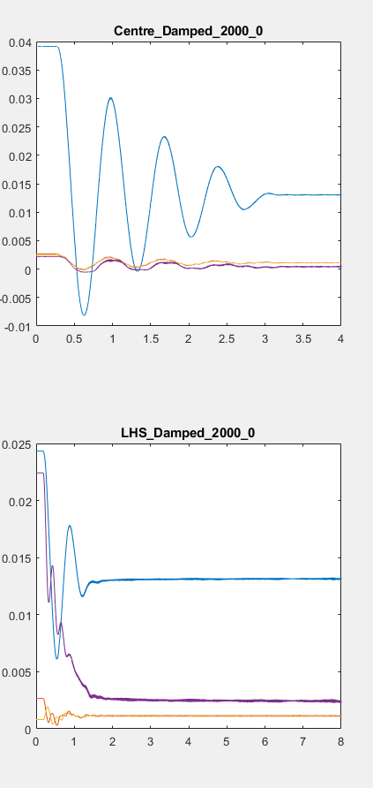

Figure Centre vs LHS

## Other Considerations

**Steady state:** Steady state for measured data does not settle at zero (+0.01m). Data is as expected (sign wave). Preliminary count of frequency validates later FFT. Steady state offset input option has been accounted for in our model.

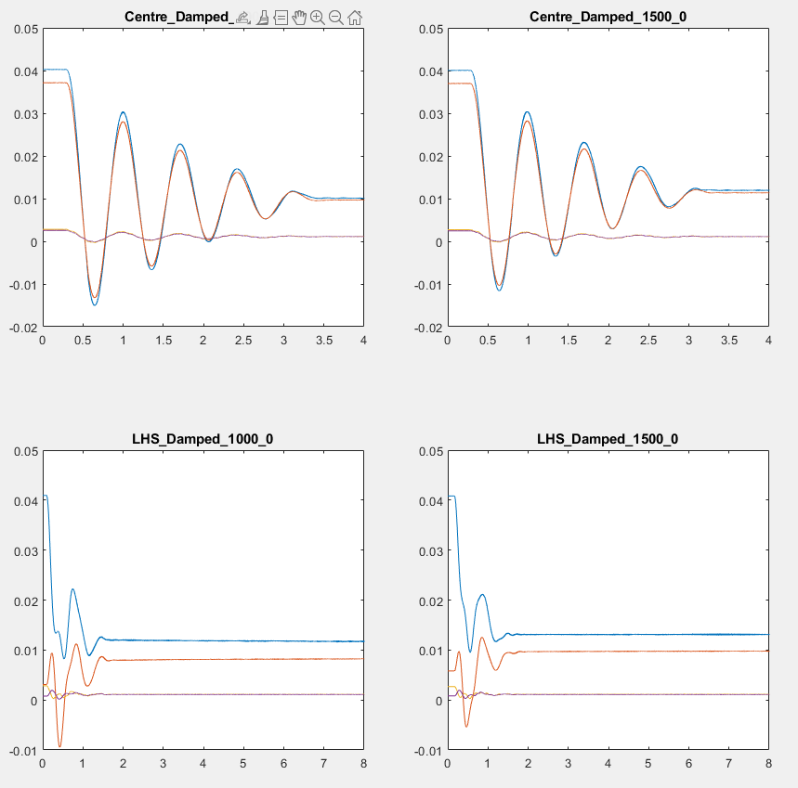

Figure Settling time Centre vs LHS.

**Natural frequency selection:** Coded in MATLAB to find peaks for all 4 DOF and then sort and pick the top 4 highest peaks. Show these peaks marked on a graph as well to see which are ‘true peaks’ as some DOF didn’t have four peak frequencies hence some must be discounted. Biggest peaks indicate natural frequencies. Lab data was not as obvious as simulated data. Both lab and simulated data show very little in magnitude (ten to the power negatives)

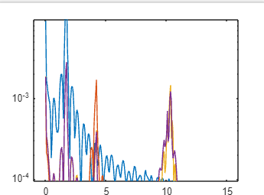

Figure FFT centre no damping no mass – simulated.

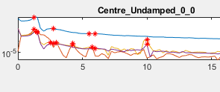

Figure Lab data FFT – centre, undamped, no mass

**Phase information:** Phase used to make mode shapes. Magnitude was normalised to graph them. Results were validated with the heat map. Results were not entirely obvious, but simulation confirms what was expected (bounce and roll in phase and out of phase for LHS and centre)

**Transfer function:** Attempted to determine transfer function mathematically for model and lab data. Used cross power spectral density analysis with Hann window overlap of /2. Phase of transfer function is negative which is good as it experienced an initial force. CPSD related to welch – taking relationship between input and output signal.

Transfer function - Welch model from lab data

From input "u1" to output "y1":

$$\frac{-0.004044 s^{2} - 3.482e-06 s + 2.105e-05}{s^{3} + 0.1543 s^{2} + 0.01265 s + 0.0004099}$$

It was not possible to calculate transfer function for simulated data due to a lack of data. We were restrained by run time and analysis. Future studies should look to increase the amount of data collected per simulated run.

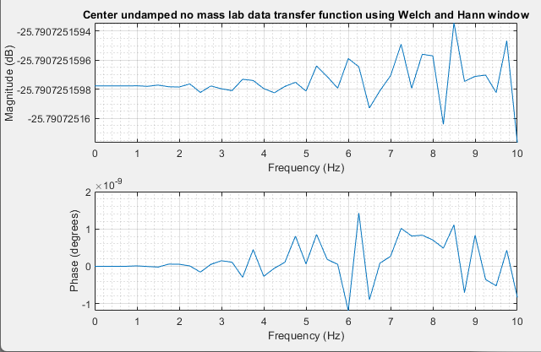

Figure : Diagram of phase and magnitude of frequency using CPSD function**.**

**DOF dominance**

Blue = m1 bounce,

Orange = m1 roll

Purple and yellow = m2 and m3 bounce (m2 RHS)

Trends are… blue (m1 bounce) overall dominant. M1 bounce and m1 roll dominant for LHS. Frequencies in phase for centre, almost no bounce. Frequencies out of phase when dropping LHS (RHS -ve first)

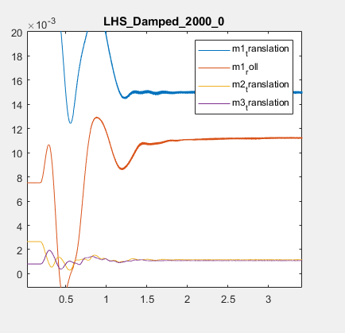

Figure : Zoom in of modes of vibration with legend.

**Other considerations**

* Are the springs up to scratch? Halved spring stiffness, FFT not really any different. Potentially, spring stiffness that large a factor in this weight range
* Adding padding not any more useful if anything made the data less readable. Disregarded.
* Change sampling frequency for lab data. Discussed especially because res from lab data is 0.25, resolution we have from simulation 0.125.

# Limitations & room for improvement

## Limitations of data collection

* Should have collected for 8 seconds consistently w no interference (some data sets have artifacts due to human interference)
* Losses:
  + friction (contact points and bearings)
  + heat (springs and hydraulic system)
* LDVT set points (using double sided tape for some LVDT). Calibration: we did not calibrate the LVDTs, trusting it was done adequately
* Initial displacement – accounted for (?)
* Average of 3 data sets, more repetitions would have been better.
* Spectral resolution for lab data 0.25, would prefer better resolution.
* Inconsistency of damping setpoint when measuring
* Simulation data much less than actual lab data (256 vs 20000 for lab data)
* Human error when dropping crane, waiting for 8 second duration and touching/leaning on rig in the meantime.
* Standardized data collection protocol: Establish a clear and standardized protocol for data collection to ensure consistency across all experiments. This should include specific instructions on minimizing human interference, such as avoiding touching or leaning on the rig during data collection.
* Improved artifact detection and removal: Implement advanced techniques to identify and remove artifacts caused by human interference, such as filtering algorithms or signal processing methods. This will help to obtain cleaner and more accurate data.
* Calibration of LVDTs: Properly calibrate the LVDTs to ensure accurate and reliable measurements. Regular calibration checks should be conducted to maintain their accuracy throughout the data collection process.
* Higher spectral resolution: Utilize equipment or techniques that provide better spectral resolution, allowing for more detailed frequency analysis of the data. This will help in identifying and analysing specific frequency components of interest.

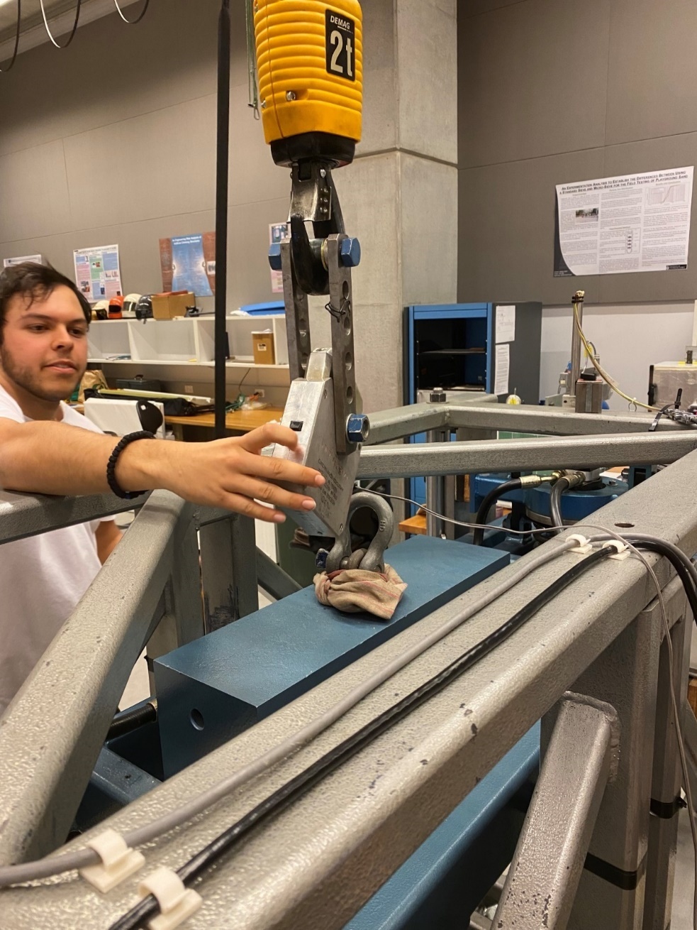

Figure Picture of dropping crane, possible reverberation, leaning.

## Model limitations

* Simplified.
* Free response is limiting because of large energy losses due to damping and quick time to steady state (return to zero). Limiting the period of data collection. Also, 1 impulse, key frequency all less than 10. Need more excitement to get higher frequencies, only lower range possible for this excitation.

# Conclusion

This report entails a successful comparison between modelled data and experimental data for the UTS half car rig bounce and roll modes. Key takeaways were the identification of a critical damping value, trends regarding mass, damping and point of release, discussion around losses and potential areas for improvement. The development of the model, simulation and transfer functions are evidence of expertise and experience in practical dynamics and controls applications.

# References

Bulatovic, R. M. (2002). On the critical damping in multi-degree-of-freedom systems. Mechanics Research Communications, 29(5), 315–319. https://doi.org/10.1016/S0093-6413(02)00263-X

Konieczny,L. Burdzik, R. Folega, P. Wieczorek, A. N. (2013). Determination of the damping characteristics of hydro pneumatic suspension strut. Journal of Measurements in Engineering, 1(3).

Pesterev, A. & Bergman, LA & Tan, Carissa. (2004). A novel approach to the calculation of pothole-induced contact forces in MDOF vehicle models. Journal of Sound and Vibration. 275. 10.1016/S0022-460X (03)00789-2.

Smith, Wade & Zhang, Nong & Jeyakumaran, Jeku. (2010). Hydraulically interconnected vehicle suspension: Theoretical and experimental ride analysis. Vehicle System Dynamics - VEH SYST DYN. 48. 41-64. 10.1080/00423110903243190.

Zhang, N., Smith, W.A. & Jeyakumaran. J. (2010). Hydraulically interconnected vehicle suspension: background and modelling. Vehicle System Dynamics, 48(1): p. 17-40.

# Appendices:

## Appendix A: Safety Form

* See attached safety form.



## Appendix B: Experiment set-up pictures

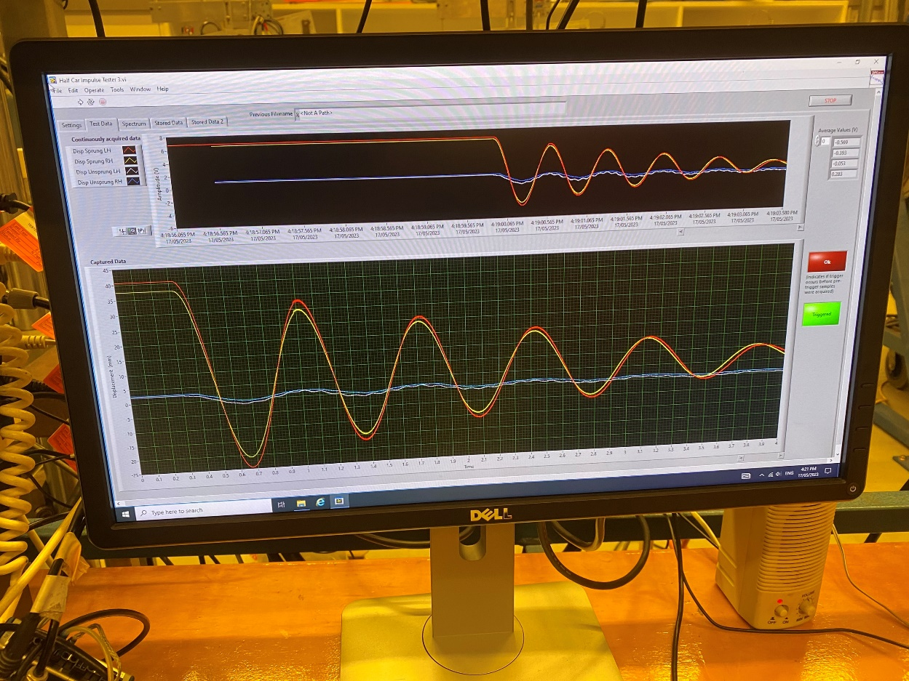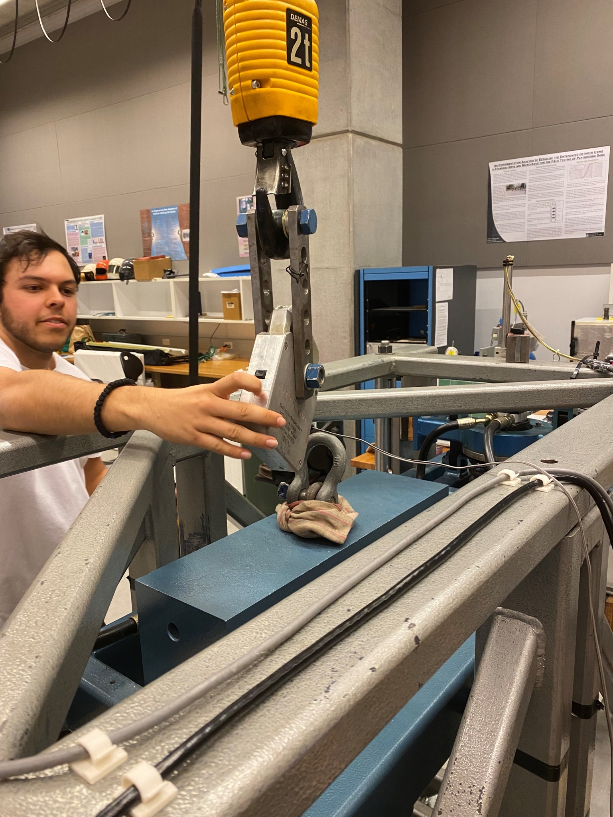

Picture X: 